[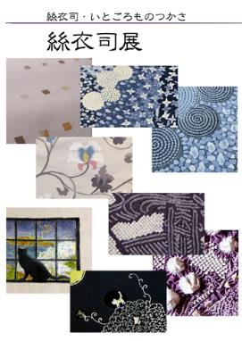](https://some-no-takako.jp/doc_pdf/itogoromo_202001.pdf)